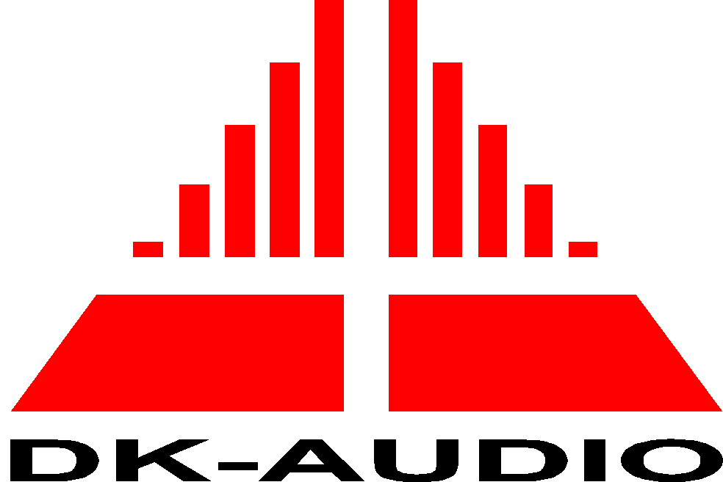


EC Declaration of Conformity
In accordance with EN 45014

We: DK-Audio

of Marielundvej 37D – 2730 Herlev - Denmark

declare under our sole responsibility that the product

Equipment type Varitime Digital Sync Generator.
Model name PT 5210 (including available options)

Serial number

to which this declaration relates is in conformity with the following product family standard(s) and used basic standards in accordance to the following Directives:

73/23/EEC Low Voltage Directive (and its amending directives)

89/336/EEC Electromagnetic Compatibility Directive (and its amending directives)

(Emission)

EN 50081-1/ 1992 Radiated electromagnetic field emission

(Immunity)

EN 50082-1/ 1992

(Safety Requirements)

IEC1010-1:1990, amendment 1:1992 :
Safety Requirements for measurement, control and laboratory use.

Signed by:

Name: Karsten Hansen

Position: CEO

Place of Issue: Marielundvej 37

Date:

